Automated Credit Risk Categorization for
Loan Approval

Project Id: AIML-5

Name : Mohd Uvais Ahmed (Team Leader)
Class Roll Number:50
University Roll Number : 2028770
Section and Group: G G2

Name : Mohammad Rayyan Farooqui
Class Roll Number:49
University Roll Number : 2028768
Section and group ; G and G2

Table of Contents
1. Introduction
1.1 Project Objectives
1.2 Scope of the Report
2. System Architecture and Flow
2.1 Pipeline Overview
3. Phase 1: Exploratory Data Analysis and Preprocessing
3.1 Dataset Description
3.2 Data Loading and Initial Exploration
3.3 Missing Value Handling
3.4 Outlier Treatment using IQR Method
3.5 One-Hot Encoding of Categorical Variables
3.6 Exploratory Visualizations
3.7 Feature Engineering
3.8 Feature Scaling
4. Phase 2: Model Training and Evaluation
4.1 Train-Test Split Details
4.2 Models Implemented
4.3 Feature Optimization Techniques
5. Evaluation Metrics
5.1 Confusion Matrix
5.2 Metric Formulas and Interpretations
5.3 Why Recall Was Prioritized Over Accuracy
6. Experimental Results
6.1 Individual Model Performance
6.2 Consolidated Model Comparison
6.3 Best Model Selection
7. Phase 3: Prediction System Implementation
7.1 Prediction Pipeline Architecture
7.2 Preprocessing Consistency
7.3 Full-Feature and Selected-Feature Prediction Systems
8. Python Modules and Development Platforms
8.1 Libraries Used
8.2 Development Platforms
9. Future Scope
10. Conclusion
11. References

1. Introduction
The financial sector faces persistent challenges in evaluating loan applicants due to the inherent risk of default. Traditional rule-based systems often fail to capture the complex, non-linear patterns present in large-scale financial datasets. Machine learning offers a data-driven, intelligent alternative that can systematically classify applicants based on their financial profiles, thereby reducing exposure to financial losses for banks and lending institutions.

This project, titled Automated Credit Risk Categorization for Loan Approval, develops a complete end-to-end machine learning pipeline that ingests financial data, preprocesses it thoroughly, trains and compares three classification models, evaluates their performance against domain-relevant metrics, and deploys an interactive prediction system. The binary target variable takes the value 0 for a Safe Loan and 1 for a Risky or Default Loan.

1.1 Project Objectives
- To explore and preprocess a banking dataset of approximately 1000–1500 records and 32 columns (post-encoding) with features including income, Credit_Score, loan_amount, and dtir1.
- To engineer domain-relevant features that improve model discrimination between safe and risky applicants.
- To train, tune, and evaluate three classification models: Logistic Regression, K-Nearest Neighbors (KNN), and Support Vector Machine (SVM).
- To select the best-performing model based on Recall, the primary metric for credit risk prediction.
- To build a complete prediction pipeline accepting manual user input and returning loan risk classification.

1.2 Scope of the Report
This Phase 3 report integrates all project phases into a consolidated academic document. It presents the complete ML workflow from raw data loading through model training, comparative evaluation, and deployment of the prediction logic. All reported metrics are based on actual experimental results obtained during implementation.

2. System Architecture and Flow
The overall system architecture is organized into three sequential phases. Raw data enters through the preprocessing pipeline, is transformed and used for model training, and ultimately powers a user-facing prediction system. The diagram below captures the complete flow.

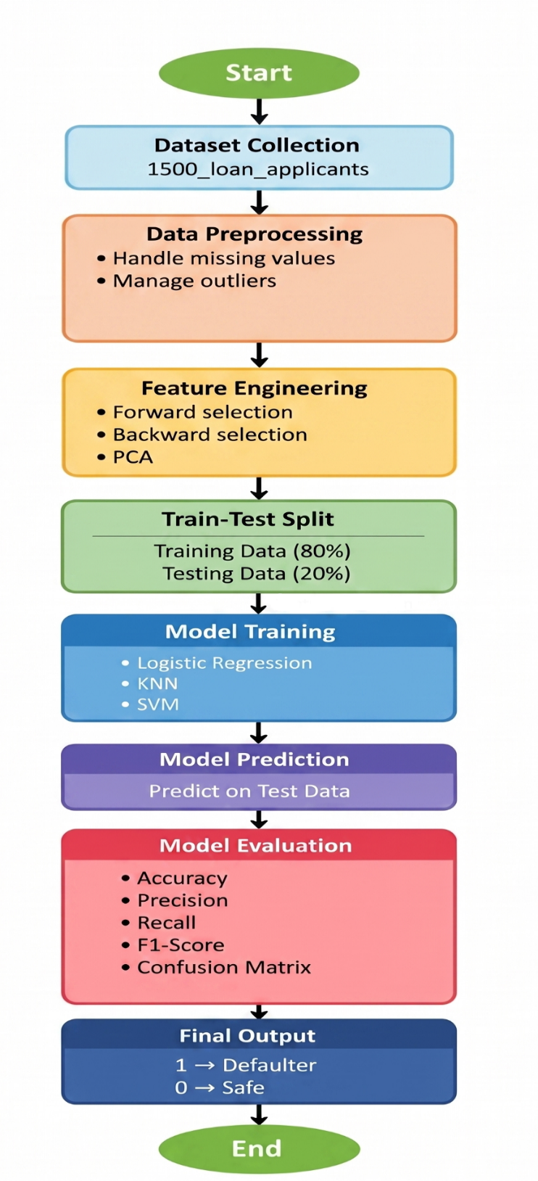
Fig. 1: End-to-End Machine Learning Pipeline for Loan Default Prediction

Table 1: Phase-wise Project Activities

3. Phase 1: Exploratory Data Analysis and Preprocessing
Phase 1 constitutes the foundational step of the project. The quality of model predictions is directly determined by the quality of the data supplied to the model. This phase addresses data loading, cleaning, imputation, outlier treatment, encoding, feature engineering, and scaling.

3.1 Dataset Description
The dataset is a financial and banking dataset sourced as cleaned_2.csv. It contains approximately 1000–1500 records across 32 effective columns after encoding. Each record represents a unique loan application with attributes spanning financial behaviour, creditworthiness, and loan characteristics.

Attribute | Detail
Source File | cleaned_2.csv
Total Records | ~1000–1500
Features (post-encoding) | ~32 columns
Target Variable | Status (0 = Safe, 1 = Risky/Default)
Key Predictive Features | income, Credit_Score, loan_amount, dtir1, LTV, rate_of_interest
Feature Types | Numerical + Categorical (one-hot encoded)
Table 2: Dataset Summary

3.2 Data Loading and Initial Exploration
The dataset was loaded using pd.read_csv(). An immediately visible unnecessary column, 'Unnamed: 0' (an artifact of prior CSV exports), was detected and removed using df.drop(). Initial exploration with df.head(), df.info(), df.describe(), and df.shape() confirmed data dimensions and type distributions. The target column Status had the value distribution confirming a class imbalance with Safe loans (0) being the majority class.

.3 Missing Value Handling
Missing values were identified in numerical and categorical columns using isnull().sum(). A dual-strategy imputation approach was used to minimize information loss:
- Numerical Columns: Features like income and loan_amount used Median Imputation because it is robust against outliers in skewed financial data.
- Categorical Columns: Features like loan_type and Gender used Mode Imputation, substituting the most frequent category to preserve the feature's natural distribution.
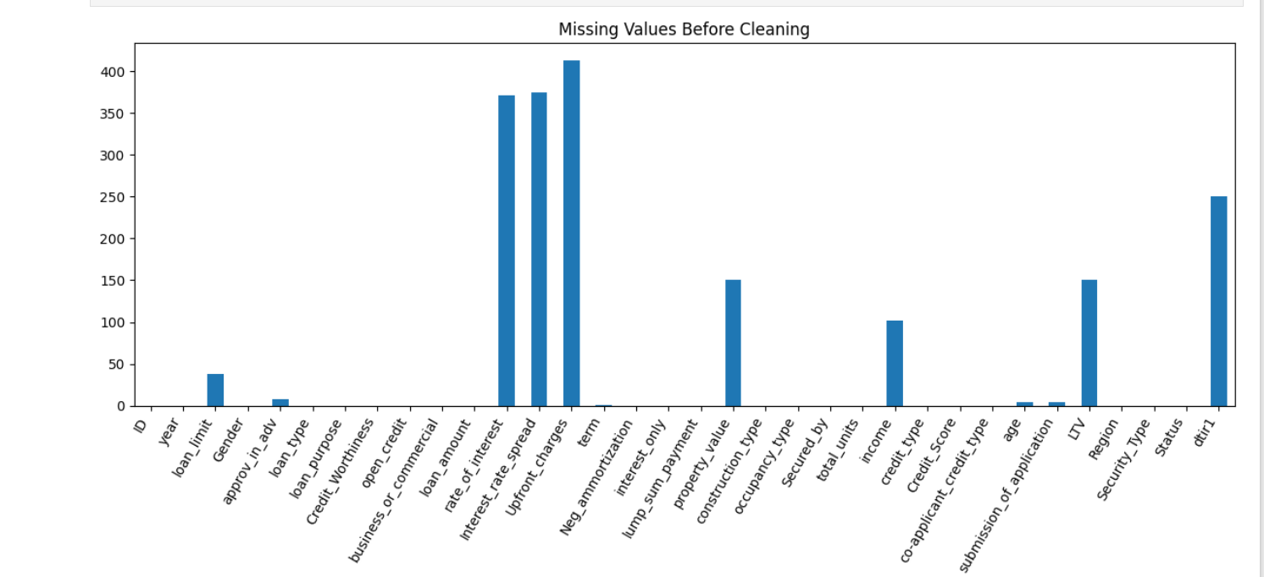
Fig. 2: Visualization of Missing Values by Feature

3.4 Outlier Treatment using IQR Method
Financial datasets often contain extreme values; in this case, loan amounts and income showed significant outlier presence. These were addressed using the Interquartile Range (IQR) capping method.
- Calculation: The lower bound was defined as $Q1 - 1.5 \times IQR$ and the upper bound as $Q3 + 1.5 \times IQR$.
- Treatment: Values outside these limits were capped (Winsorized) instead of deleted.
- Impact: This approach neutralized distortion while preserving the total record count.
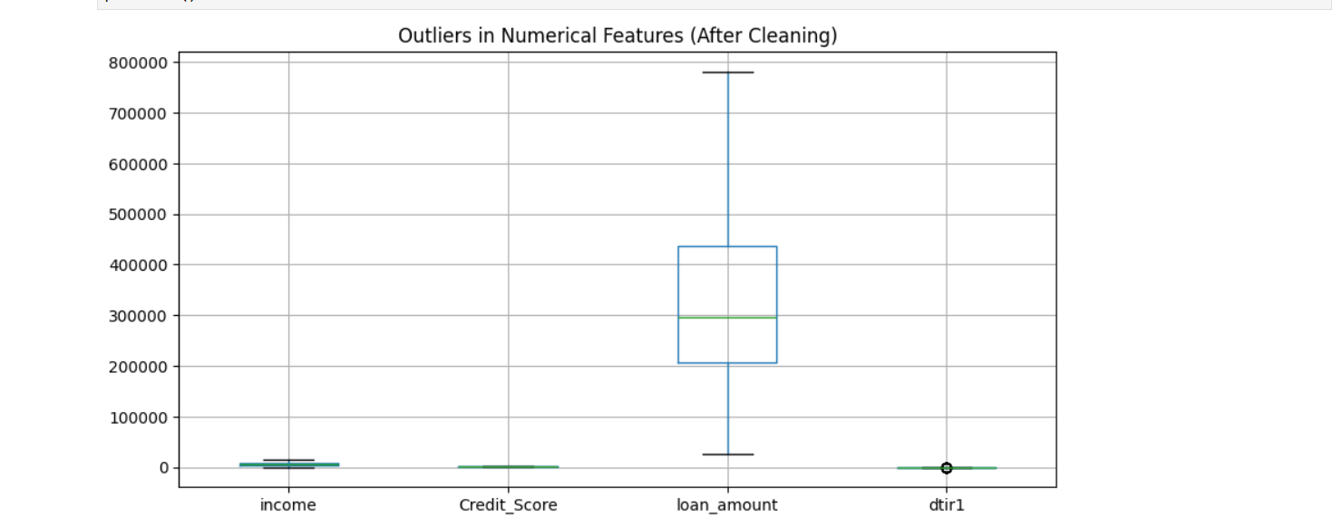.

Fig. 3: Outlier Treatment via IQR Capping on Key Numerical Features

3.5 One-Hot Encoding of Categorical Variables
All categorical columns including loan_limit, Gender, approv_in_adv, loan_type, loan_purpose, Credit_Worthiness, business_or_commercial, and credit_type were encoded using pd.get_dummies() with drop_first=True. The drop_first parameter eliminates the dummy variable trap by dropping the first category of each feature, preventing multicollinearity in the feature matrix.

3.6 Exploratory Visualizations
- Histograms: Revealed right-skewed distributions for loan_amount, income, and total_cost_proxy, confirming the need for outlier treatment.
- Boxplots: Highlighted outlier density in loan_amount and income and confirmed effectiveness of IQR capping post-treatment.
- Correlation Heatmap: Showed strong positive correlation between loan_amount and engineered features such as interest_burden and total_cost_proxy. Credit_Score showed moderate negative correlation with Status.
- Pairplots: Revealed partial visual separability between Status = 0 and Status = 1 along the Credit_Score and dtir1 axes.

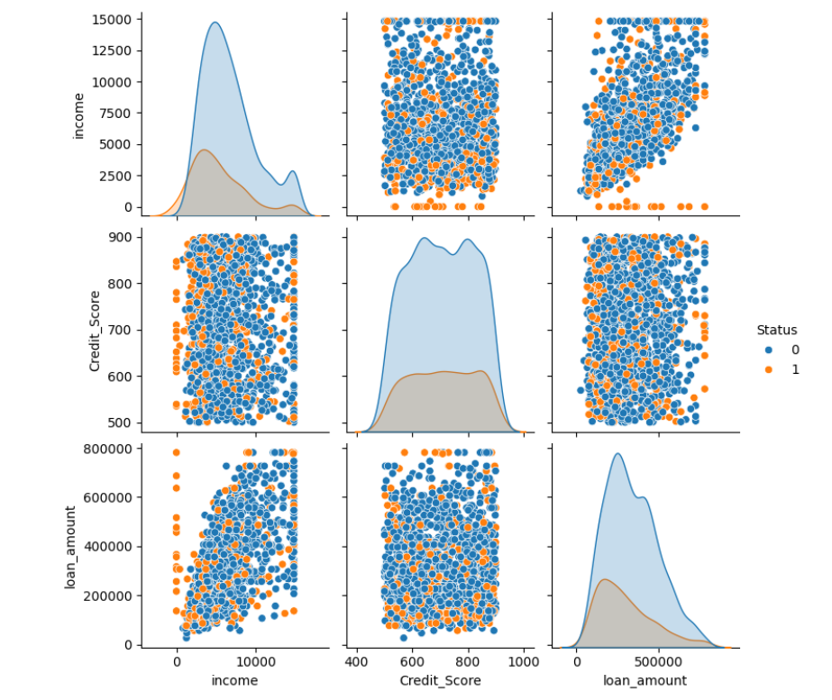
Fig. 4: Pairplot Showing Feature Interactions Coloured by Loan Status

3.7 Feature Engineering
Five engineered features were derived from existing columns to encode financial domain logic that raw features cannot capture individually:

Feature Name | Derivation Formula | Financial Rationale
loan_to_income | loan_amount / income | Repayment burden as fraction of income
loan_to_collateral | loan_amount / collateral_value | Collateral coverage adequacy
interest_burden | loan_amount * rate_of_interest | Total interest cost obligation
total_cost_proxy | loan_amount * (1 + rate_of_interest) | Approximate total repayment amount
risk_score | Composite of above features | Aggregated applicant risk index
Table 3: Engineered Features and Financial Rationale

3.8 Feature Scaling
StandardScaler was fitted exclusively on the training set and then applied to transform both the training and test sets. This prevents data leakage where test distribution information influences the scaling parameters. Scaling is critical for KNN and SVM, both of which compute distances or margins that are sensitive to the magnitude of feature values. Without scaling, features with large numerical ranges (such as loan_amount or total_cost_proxy) would dominate the distance metric, rendering other features irrelevant.

4. Phase 2: Model Training and Evaluation
Phase 2 implements, trains, and evaluates three machine learning classifiers on the preprocessed dataset. An 80:20 stratified train-test split was used with random_state=42 to ensure reproducibility and to preserve class distribution in both subsets.

4.1 Train-Test Split Details
Parameter | Value
Split Ratio | 80% Training / 20% Testing
Test Set Size | 302 samples
Class 0 (Safe) in Test Set | 227 samples (75.2%)
Class 1 (Risky) in Test Set | 75 samples (24.8%)
random_state | 42
Stratify | Yes (y)
Table 4: Train-Test Split Configuration

4.2 Models Implemented

4.2.1 Logistic Regression
Logistic Regression is a linear probabilistic classifier that models the relationship between the feature vector and the probability of class membership using the sigmoid function. It was configured with class_weight='balanced' to compensate for the class imbalance in the dataset, ensuring that the minority class (risky loans) is not under-penalized during training. The maximum iteration limit was set to 500 to allow full convergence.
P(y=1|X) = 1 / (1 + e^(-z)) where z = w0 + w1*x1 + ... + wn*xn
Logistic Regression serves as the interpretable baseline model. Its coefficients can be directly examined to understand which features contribute positively or negatively to default risk. While it cannot model non-linear decision boundaries, its simplicity and speed make it a valuable reference point.

4.2.2 K-Nearest Neighbors (KNN)
KNN is a non-parametric, lazy learning algorithm that classifies new instances based on a majority vote among their K nearest training neighbors. Euclidean distance was used as the distance metric. The model was configured with n_neighbors=3, selected after visual inspection and validation.
d(x, y) = sqrt((x1-y1)^2 + (x2-y2)^2 + ... + (xn-yn)^2)
KNN is highly sensitive to feature scale, making the preceding StandardScaler step essential. With K=3, the model is aggressive in capturing local patterns but may overfit to noise in the training set. A lower K increases sensitivity to individual training samples, while a higher K would smooth the decision boundary at the cost of recall on the minority class.

4.2.3 Support Vector Machine (SVM)
SVM was trained using an RBF (Radial Basis Function) kernel with C=5 and gamma=0.01. SVM seeks the maximum-margin hyperplane that separates classes in the transformed feature space. The RBF kernel maps the input to an infinite-dimensional space, enabling separation of non-linearly separable data.
K(xi, xj) = exp(-gamma * ||xi - xj||^2)
The regularization parameter C=5 allows moderate margin violations, balancing between a wide margin and correct classification. The gamma=0.01 value produces a relatively smooth decision boundary with broader influence per support vector, reducing the risk of overfitting to noise.

4.3 Feature Optimization Techniques

4.3.1 Forward Selection
Forward Selection begins with an empty feature set and iteratively adds the feature that most improves a chosen performance metric (Recall in this project). This continues until further additions provide negligible benefit. The technique is computationally expensive but produces a minimal, high-value feature subset.

4.3.2 Backward Elimination
Backward Elimination starts with the full feature set and removes the least contributing feature at each step, based on model performance impact or statistical significance. It is used as a complementary approach to forward selection to cross-validate the most important features.

4.3.3 Principal Component Analysis (PCA)
PCA is a dimensionality reduction technique, not a feature selection method. Unlike forward or backward selection, which retain original features, PCA transforms the entire feature space into orthogonal principal components ranked by explained variance. These components are linear combinations of all original features. While PCA reduces dimensionality and multicollinearity, the resulting components lack direct interpretability. In this project, PCA was explored as a preprocessing alternative for models sensitive to high-dimensional input.

Technique | Type | Keeps Original Features? | Output Interpretable?
Forward Selection | Feature Selection | Yes | Yes
Backward Elimination | Feature Selection | Yes | Yes
PCA | Dimensionality Reduction | No (Linear Transforms) | No
Table 5: Feature Optimization Technique Comparison

5. Evaluation Metrics
Given the binary classification nature of this problem and the asymmetric cost of prediction errors in financial applications, a comprehensive set of metrics was employed beyond simple accuracy.

5.1 Confusion Matrix
The confusion matrix tabulates the four outcome categories for a binary classifier:

 | Predicted: Safe (0) | Predicted: Risky (1)
Actual: Safe (0) | True Negative (TN) – Correct safe | False Positive (FP) – Unnecessary rejection
Actual: Risky (1) | False Negative (FN) – DANGEROUS | True Positive (TP) – Correctly caught risk
Table 6: Confusion Matrix Structure

False Negatives are the most dangerous outcome in this domain. Predicting a risky applicant as safe results in loan approval for a likely defaulter, causing direct financial loss to the lending institution. Minimizing FN is therefore the central optimization objective.

5.2 Metric Formulas and Interpretations
Accuracy:
Accuracy = (TP + TN) / (TP + TN + FP + FN)
Measures overall correctness across both classes. Can be misleading when classes are imbalanced.

Precision:
Precision = TP / (TP + FP)
Of all applicants predicted as risky, how many were actually risky. High precision reduces unnecessary loan rejections.

Recall (Sensitivity):
Recall = TP / (TP + FN)
Of all actual risky applicants, how many were correctly identified. This is the PRIMARY metric for credit risk prediction as it directly quantifies the model's ability to catch defaulters.

F1-Score:
F1-Score = 2 * (Precision * Recall) / (Precision + Recall)
Harmonic mean of precision and recall. Provides a balanced single-number summary when both false positives and false negatives matter.

5.3 Why Recall Was Prioritized Over Accuracy
In this project, the test set contained 227 safe and 75 risky applicants. A naive model predicting all applicants as safe would achieve 75.2% accuracy while completely failing to detect any defaulter, achieving 0% recall. This illustrates why accuracy alone is an inadequate metric for imbalanced credit risk tasks. Recall and F1-Score were therefore treated as the primary success criteria throughout the evaluation phase.

6. Experimental Results
All three models were trained on the 80% training subset and evaluated on 302 test samples. Results are reported from actual experimental runs.

6.1 Individual Model Performance

6.1.1 Logistic Regression
Configured with class_weight='balanced' and max_iter=500. The balanced class weight parameter adjusts sample weights inversely proportional to class frequencies, directly compensating for the majority-class bias in the training set.

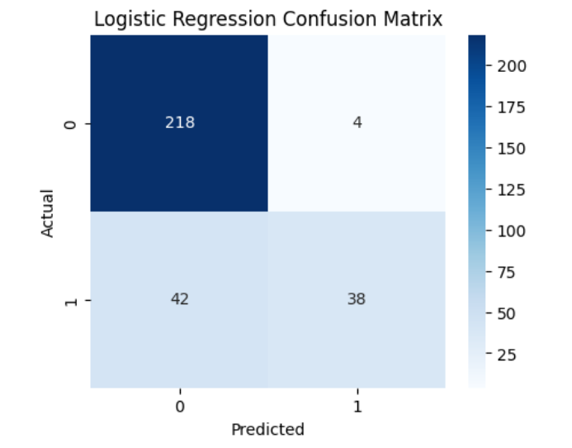
Fig. 5: Confusion Matrix – Logistic Regression

Logistic Regression achieved the highest Recall (0.627) on the risky class among all three models, making it the best performer by the primary criterion. The class_weight='balanced' parameter was key to this outcome, as it forced the model to pay greater attention to the minority class during training.

6.1.2 K-Nearest Neighbors (KNN)
Configured with n_neighbors=3. This relatively low K allows the model to capture local patterns but trades some recall for higher precision.

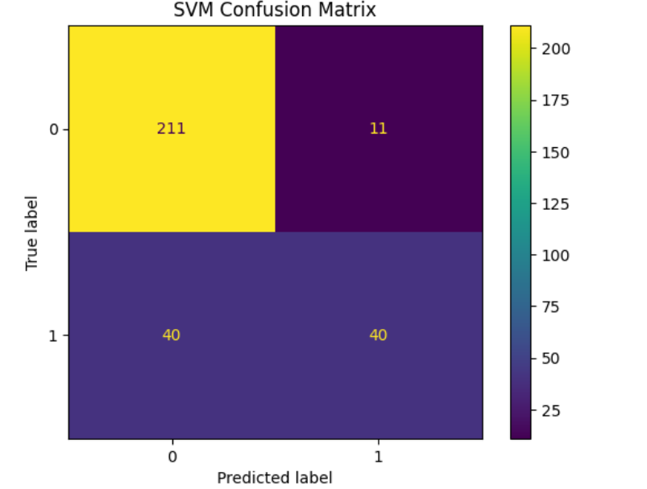
Fig. 6: Confusion Matrix – KNN (K=3)

KNN achieved higher overall accuracy (83.11%) and better precision (0.714) on the risky class compared to Logistic Regression. However, its recall dropped to 0.533, meaning it missed nearly half of all actual defaulters. This trade-off makes KNN less suitable as the primary model for this credit risk application where recall is paramount.

6.1.3 Support Vector Machine (SVM)
Configured with kernel='rbf', C=5, and gamma=0.01. The RBF kernel enables non-linear separation in a higher-dimensional feature space.

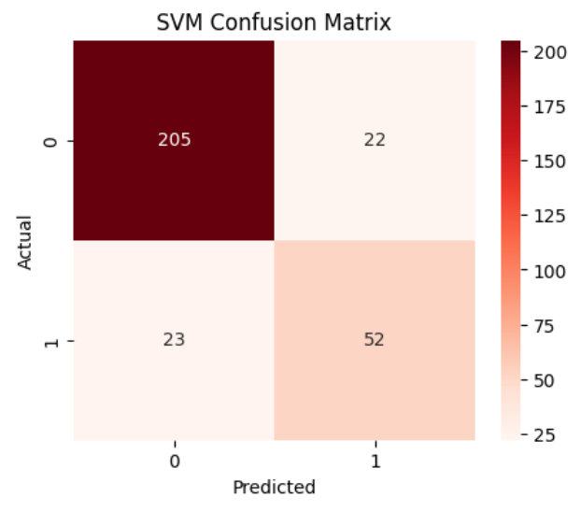
Fig. 7: Confusion Matrix – SVM with RBF Kernel

SVM achieved the highest accuracy (85.43%) and the highest precision (0.860) on the risky class, nearly eliminating false alarms. However, its recall (0.493) was the lowest of the three models, meaning it correctly identified only about 49% of actual defaulters. The model was overly conservative, heavily favouring safe predictions, likely due to the absence of class balancing in the SVM configuration.

6.2 Consolidated Model Comparison
Model | Accuracy | Precision (Class 1) | Recall (Class 1) | F1-Score (Class 1)
Logistic Regression | 79.14% | 57.32% | 62.67% | 59.87%
KNN (K=3) | 83.11% | 71.43% | 53.33% | 61.07%
SVM (RBF, C=5) | 85.43% | 86.05% | 49.33% | 62.71%
Table 10: Consolidated Model Comparison (Highlighted = Best Recall)
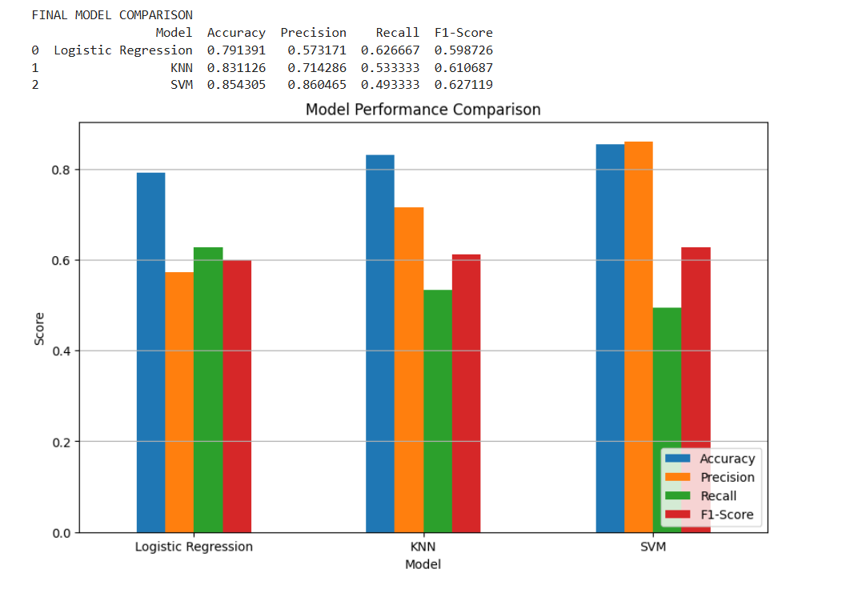
Fig. 10: Model Performance Comparison – Accuracy, Precision, Recall, F1-Score
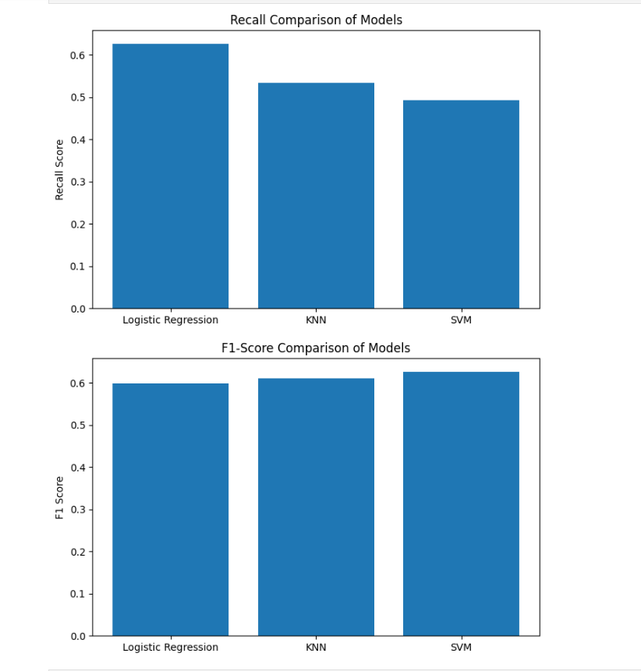Fig. 11: Recall Comparison Across Models (Primary Criterion)

–Fig. 12: F1-Score Comparison Across Models

6.3 Best Model Selection
Based on Recall as the primary evaluation criterion (minimizing False Negatives is the project's core objective), Logistic Regression was identified as the best performing model with a Recall of 0.627 on the risky class. This outcome is attributed to the class_weight='balanced' parameter which compensated for the dataset's class imbalance during training.

Criterion | Best Model | Value
Highest Recall (Primary) | Logistic Regression | 0.627
Highest Accuracy | SVM (RBF) | 85.43%
Highest Precision | SVM (RBF) | 86.05%
Highest F1-Score | SVM (RBF) | 62.71%
Table 11: Best Model by Each Criterion

The choice of the final model for deployment should consider operational priorities. If the priority is to catch maximum defaulters (minimize financial losses), Logistic Regression is recommended. If the priority is to minimize unnecessary loan rejections (false alarms), SVM provides superior precision. For a balanced deployment, further tuning of SVM with class_weight='balanced' may bridge this gap.

7. Phase 3: Prediction System Implementation
The prediction system translates the trained model into a deployable tool that accepts real applicant input and returns a risk classification. The system was built for all three models with both full-feature and selected-feature variants.

7.1 Prediction Pipeline Architecture
- User provides applicant financial data through a structured input prompt.
- Input values are assembled into a pandas DataFrame with column names exactly matching the training feature set.
- Engineered features (loan_to_income, interest_burden, etc.) are recomputed from raw inputs.
- The DataFrame is passed through the saved StandardScaler using transform() (not fit_transform()).
- The scaled feature vector is passed to the trained model's predict() method.
- The binary output (0 or 1) is mapped to a human-readable risk label and displayed.

7.2 Preprocessing Consistency
The most critical implementation requirement is that preprocessing applied at training time is identically replicated at inference time. Three specific consistency requirements were enforced:
- The StandardScaler instance fitted on X_train_scaled was saved and reused for all prediction inputs without re-fitting.
- The column order in the prediction DataFrame was enforced to match the order present in X_train, as scikit-learn models are order-sensitive.
- Engineered features were recomputed from raw inputs before scaling, replicating the exact feature engineering sequence from Phase 1.

7.3 Full-Feature and Selected-Feature Prediction Systems
Two variants of the prediction system were developed. The Full-Feature Prediction System uses all 32 post-encoding features including the five engineered features, providing the highest fidelity. The Selected-Feature Prediction System uses a condensed input set of the most informative features (income, Credit_Score, loan_amount, dtir1, rate_of_interest, and the key engineered features) identified through forward and backward selection. The selected-feature system maintained performance comparable to the full-feature system, validating the feature selection process.

Prediction Output | Interpretation | Recommended Action
0 (Safe Loan) | Applicant is classified as a low-risk borrower | Loan approval may be considered
1 (Risky / Default) | Applicant is classified as a high-risk borrower | Further verification or rejection advised
Table 12: Prediction Output Interpretation

8. Python Modules and Development Platforms

8.1 Libraries Used
Library / Module | Function in Project
pandas | Data loading, cleaning, imputation, DataFrame creation for prediction input
numpy | Numerical operations, array manipulation, statistical computations
matplotlib.pyplot | Plotting bar charts, recall comparison graphs, model comparison visualizations
seaborn | Heatmaps, pairplots, confusion matrix visualization using sns.heatmap()
sklearn.model_selection.train_test_split | Stratified 80:20 data splitting with fixed random_state=42
sklearn.preprocessing.StandardScaler | Standardizing features to zero mean and unit variance
sklearn.linear_model.LogisticRegression | Training baseline classifier with class_weight='balanced'
sklearn.neighbors.KNeighborsClassifier | Training distance-based classifier with n_neighbors=3
sklearn.svm.SVC | Training SVM with RBF kernel, C=5, gamma=0.01
sklearn.decomposition.PCA | Dimensionality reduction for feature optimization exploration
sklearn.metrics.confusion_matrix | Generating confusion matrices for all three models
sklearn.metrics.classification_report | Producing full precision, recall, F1, and accuracy reports
sklearn.metrics.accuracy_score, precision_score, recall_score, f1_score | Individual metric extraction for results DataFrame and comparison charts
Table 15: Python Libraries and Their Roles in This Project

8.2 Development Platforms

8.2.1 Jupyter Notebook
Jupyter Notebook was the primary development environment for Phase 1 and Phase 2. Its cell-by-cell execution model supported iterative exploration, inline visualization, and rapid debugging. All EDA visualizations and model training experiments were conducted in Jupyter.

8.2.2 Visual Studio Code
VS Code was used for structured Python scripting in Phase 3. The prediction system was developed as standalone Python scripts, leveraging VS Code's debugging tools, integrated terminal, and Python IntelliSense.

8.2.3 Python 3.x
Python 3 served as the sole programming language throughout the project. Its rich scientific computing ecosystem, readability, and wide community support made it the natural choice for all data processing, modeling, and deployment tasks.

9. Future Scope
- SMOTE Integration: Apply Synthetic Minority Over-sampling Technique to generate synthetic samples for the risky class, improving recall for all models including KNN and SVM.
- Real-Time Deployment as API: Convert the prediction pipeline into a REST API using FastAPI or Flask, enabling integration with banking front-end systems for live applicant evaluation.
- Web Application Development: Build a Streamlit or React-based interface for non-technical bank staff to interact with the prediction system through a user-friendly portal.
- Larger and More Diverse Datasets: Training on multi-institution, multi-region datasets would significantly improve model robustness and reduce geographic and demographic bias.
- Deep Learning Exploration: Feedforward neural networks and attention-based models may capture subtle non-linear interactions between financial features that tree-based and kernel methods miss.
- Explainability with SHAP: Integrate SHAP (SHapley Additive exPlanations) to provide feature-level explanations for individual predictions, which is critical for regulatory compliance and borrower transparency.
- Integration with Credit Bureau APIs: Connect to live APIs such as CIBIL or Experian to retrieve real-time credit scores and repayment histories at prediction time.

10. Conclusion
This project successfully delivered a complete, end-to-end machine learning pipeline for automated credit risk categorization. Beginning with the raw banking dataset and progressing through systematic preprocessing, domain-informed feature engineering, model training, comparative evaluation, and deployment of a prediction system, the project mirrors a real-world ML workflow applicable to financial institutions.

Three classification models were implemented and rigorously evaluated: Logistic Regression served as the interpretable, recall-optimized baseline; KNN provided strong accuracy with distance-based flexibility; and SVM with the RBF kernel demonstrated the highest overall accuracy and precision. Critically, the experimental results revealed that Logistic Regression with class_weight='balanced' achieved the highest recall (62.67%) on the risky class, making it the most suitable model for deployment in a risk-averse lending environment where missing a defaulter carries the highest cost.

The project reinforced fundamental machine learning principles: the critical importance of data quality and preprocessing, the necessity of recall over accuracy in imbalanced classification problems, the effect of feature scaling on distance-based models, and the practical challenges of maintaining preprocessing consistency between training and inference. The developed prediction system provides a functional foundation that can, with further engineering, be integrated into a production banking environment to support safer, more intelligent lending decisions.

11. References
- GeeksforGeeks. (2024). Machine Learning Tutorials – Classification, SVM, KNN, Logistic Regression. Available at: https://www.geeksforgeeks.org/machine-learning/
- Scikit-learn Development Team. (2024). Scikit-learn User Guide: Supervised Learning, Preprocessing, and Model Evaluation. Available at: https://scikit-learn.org/stable/user_guide.html
- Stack Overflow Community. (2024). Q&A Threads on Python, pandas, scikit-learn. Available at: https://stackoverflow.com
- Python Software Foundation. (2024). Python 3.x Official Documentation. Available at: https://docs.python.org/3/
- Kanetkar, Y. (2022). Let Us Python (3rd ed.). BPB Publications, New Delhi.
- Pandas Development Team. (2024). pandas Documentation (v2.x). Available at: https://pandas.pydata.org/docs/
- Hunter, J. D. (2007). Matplotlib: A 2D Graphics Environment. Computing in Science & Engineering, 9(3), 90–95.
- Waskom, M. (2021). seaborn: Statistical Data Visualization. Journal of Open Source Software, 6(60), 3021. doi:10.21105/joss.03021

